================================================
HANDS-ON SUBMISSION
Topic: JPA vs Hibernate vs Spring Data JPA
================================================
1. WHAT IS JPA?
---------------
- JPA is a set of rules for storing Java objects in a database
- It does not run any code by itself, it only defines how things should work
- Hibernate is a tool that follows these rules
-----------------------------------------------
2. WHAT IS HIBERNATE?
----------------------
- Hibernate is a tool that implements JPA
- It converts Java objects into database rows
- It writes and runs the SQL queries automatically
-----------------------------------------------
3. WHAT IS SPRING DATA JPA?
----------------------------
- It sits on top of Hibernate
- It reduces the amount of code we need to write
- It handles transactions automatically using @Transactional
- It gives us free methods like save(), findAll(), findById()
------------------------------------------------
4. CODE COMPARISON
-------------------
Hibernate way (we write everything manually):
Session session = factory.openSession();
Transaction tx = session.beginTransaction();
session.save(employee);
tx.commit();
session.close();
-- around 20 lines of code just to save one record

Spring Data JPA way (Spring handles everything):

employeeRepository.save(employee);
-- just 1 line to do the same thing
------------------------------------------------
5. HOW THEY WORK TOGETHER
-------------------------
Our Code --> Spring Data JPA --> Hibernate --> JPA --> MySQL
- JPA = the rules
- Hibernate = follows the rules and runs SQL
- Spring Data JPA = makes it easier to use Hibernate
------------------------------------------------
6. SCREENSHOTS FROM ORM-LEARN PROJECT
---------------------------------------
Screenshot 1 - VS Code showing project files:
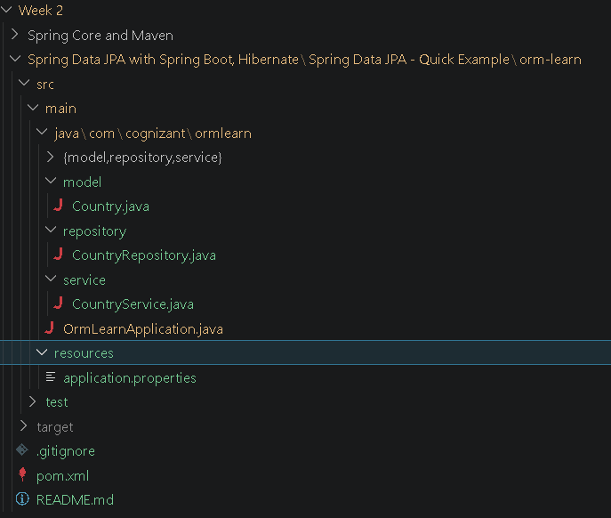
Screenshot 2 - Terminal showing BUILD SUCCESS:
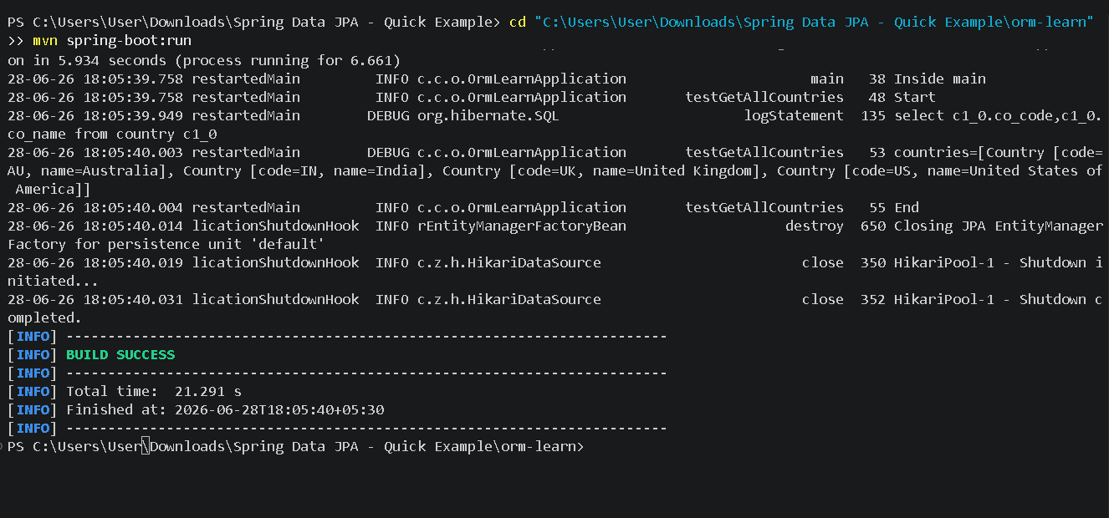

Screenshot 3 - MySQL country table data:
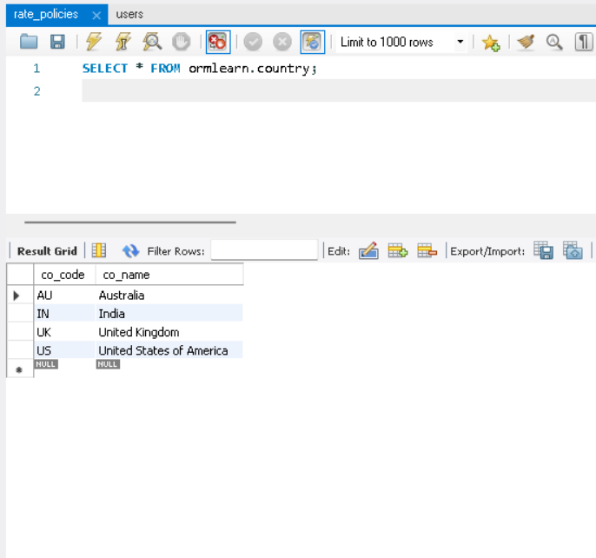

------------------------------------------------

Thank you
================================================

